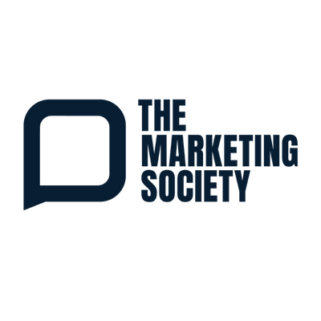
THE GLOBAL CHANGEMAKERS CONFERENCE 2026:
MAKING THE CASE TO ATTEND
A ready-to-send email to help you get approval to attend the Global Changemakers Conference 2026: Ambition on Wednesday 11 November at the QEII Conference Centre, London. Simply add your manager’s name and adjust the three focus areas to match your own priorities.
Subject: Request: The Marketing Society Global Changemakers Conference, 11 November
Hi [Name],
I’d like to request approval to attend The Marketing Society’s Global Changemakers Conference on Wednesday 11 November at the QEII Conference Centre in London. It runs from 8:30am to 5:00pm, so it is a single day out of the office.
This year’s theme is Changemakers: Ambition, and it feels very relevant to where we are as a business. The focus is on marketers taking their place at the heart of growth and leadership, and on setting bigger goals rather than settling for incremental gains. That is exactly the conversation I’d like us to be having as we plan for next year.
The line-up is broad and practical, with speakers from well beyond the usual marketing circuit. Simon Eyles, Co-CEO of Bettys and Taylors of Harrogate, will share how Yorkshire Tea became the number one tea brand by staying the course, and serial entrepreneur Marcia Kilgore will talk about what ambition looks like after founding five brands, including Soap & Glory, FitFlop and Beauty Pie. China analyst Christina Boutrup will show how far ahead China already is, from robotic factory floors to drone deliveries, while Libby Jackson OBE, former Flight Director at Mission Control, will cover judgement and decision making under pressure. It is a single-track day, so every session is relevant and nothing is missed. There are three areas in particular I’d like to bring back for us:
- Commercial ambition: how leading brands set bigger goals and stay the course long enough to build lasting growth.
- Leadership and decision making: how to make good calls under pressure, build trust and get the best from a team made up of very different people.
- The future of consumers, technology and work: what is already happening in markets like China, and the human skills that AI can’t replace.
As we’re already Members of The Marketing Society, this is one of the best ways to get full value from our membership. I’ll be in a room with around 450 of the industry’s most senior marketers who are working through the same challenges we are, and the learning carries on afterwards. The Edit, the Member newsletter, will include a round-up of the conference at the end of November, with session notes and reviews on the website, so the wider team can revisit the key ideas.
Our membership may already include a conference ticket, which I can claim through the website at no extra cost. If it doesn’t, Member tickets are £795 + VAT, and a Member + Guest ticket is £1,595 + VAT if someone else in the team would benefit from coming too.
The day is built around practical ideas we can apply straight away rather than theory. Within a week of the conference I’ll share a summary with the team, covering the key ideas and three actions we can put in place.
Do I have your support to go ahead and book?
Thanks,
[Your Name]

