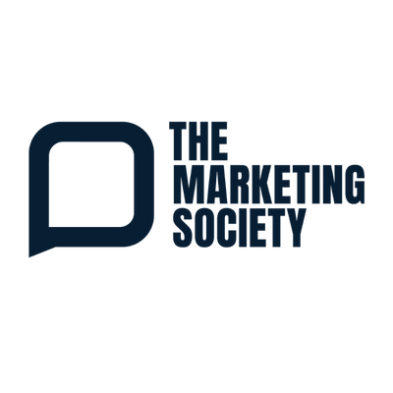
THE GLOBAL CHANGEMAKERS CONFERENCE 2026:
MAKING THE CASE TO ATTEND
A ready-to-send email to help you get approval to attend the Global Changemakers Conference 2026: Ambition on Wednesday 11 November at the QEII Conference Centre, London. Simply add your manager’s name and adjust the three focus areas to match your own priorities.

Subject: Request: The Global Changemakers Conference 2026, 11 November
Hi [Name],
I’d like to request approval to attend the Global Changemakers Conference, run by The Marketing Society, on Wednesday 11 November at the QEII Conference Centre in London. It runs from 8:30am to 5:00pm.
The Marketing Society is a global membership organisation for senior marketing leaders, and this is its flagship conference, bringing together around 450 senior marketers for a day of practical, focused content. This year’s theme is Changemakers: Ambition, which is about marketers taking their place at the heart of business growth and leadership. With the pressure we’re under to show the commercial value of marketing, it feels very relevant to what we’re working through right now.
The line-up stands out because it goes well beyond the usual marketing conference. Simon Eyles, Co-CEO of Bettys and Taylors of Harrogate, will share how Yorkshire Tea became the number one tea brand, and Sophie Whybrew-Bond, Chief Commercial Officer at the Royal Ballet and Opera, will talk about reimagining a centuries-old institution, from major brand partnerships to TikTok. Major Scotty Mills will cover building high-performing teams from very different people, Dr Hannah Critchlow will look at the human skills AI can’t replace, and Nir Eyal will explain how changing what you believe unlocks motivation and resilience. It runs as a single track, so the whole day is focused content rather than a choice of breakout sessions. There are three areas in particular I’d like to bring back for us:
- Commercial ambition: how leading brands set bigger goals and stay the course long enough to build lasting growth.
- Leadership and decision making: how to make good calls under pressure, build trust and get the best from a team made up of very different people.
- The future of consumers, technology and work: what is already happening in markets like China, and the human skills that AI can’t replace.
Past attendees rate it highly, with one saying they felt they’d got complete ROI within the first hour. Reviews and coverage of the sessions are published afterwards, so there will be plenty to share with the wider team.
Tickets are £945 + VAT. It would also be a good chance to see whether membership of The Marketing Society could be worthwhile for us, as Members receive a discounted conference rate along with year-round events, insight and networking.
Within a week of the conference I’ll share a summary with the team, covering the key ideas and three practical actions we can put in place.
Do I have your support to go ahead and book?
Thanks,
[Your Name]

